#
# 20200218
# Test ssl certificate expiration date.
# https://www.shellhacks.com/ru/openssl-check-ssl-certificate-expiration-date/
# https://ma.ttias.be/how-to-read-ssl-certificate-info-from-the-cli/

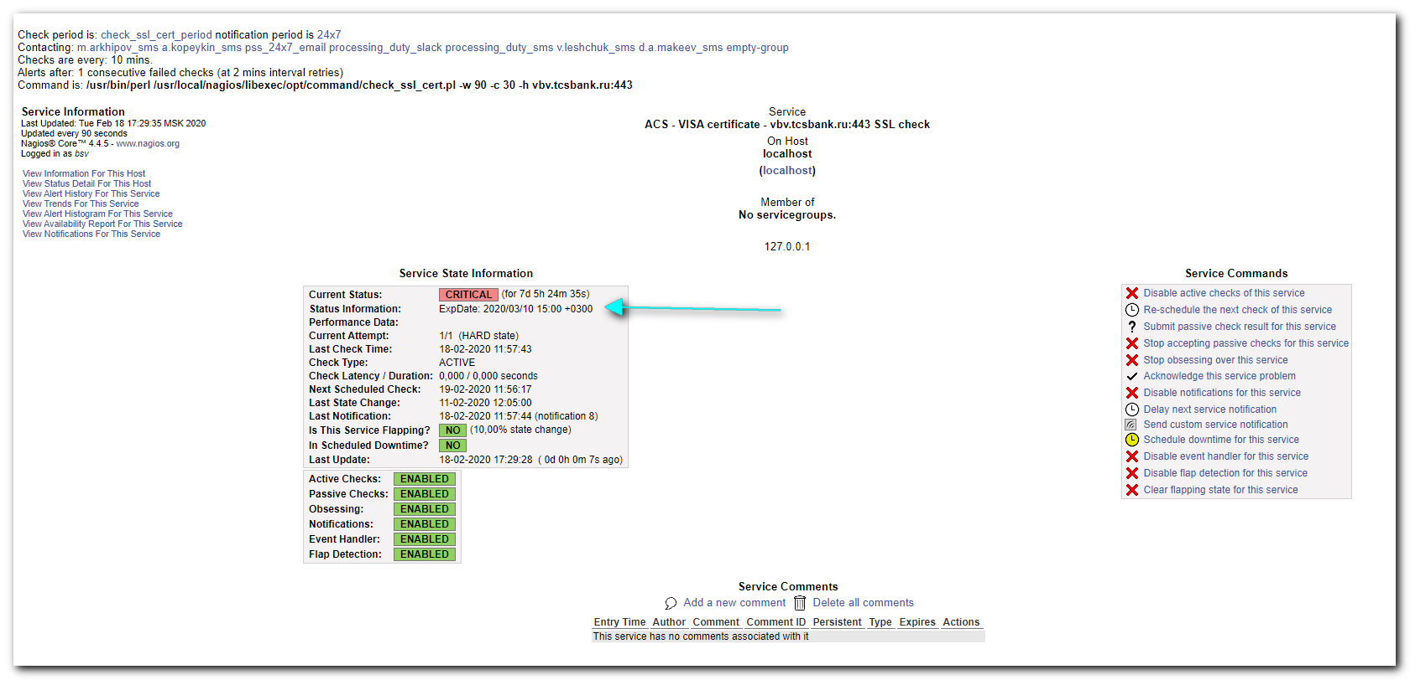

#
# This is how to test ssl certificate expiration date from command line.
#
[root@vm-vol-nag4-tst objects]# echo | openssl s_client -servername vbv.tcsbank.ru -connect vbv.tcsbank.ru:443 2>/dev/null | openssl x509 -noout -dates
notBefore=Jan 10 00:00:00 2018 GMT
notAfter=Mar 10 12:00:00 2020 GMT
[root@vm-vol-nag4-tst objects]#

# Get more info about ssl certificate.
#
[root@vm-vol-nag4-tst objects]# echo | openssl s_client -servername vbv.tcsbank.ru -connect vbv.tcsbank.ru:443 2>/dev/null | openssl x509 -noout -issuer -subject -dates
issuer= /C=US/O=DigiCert Inc/OU=www.digicert.com/CN=Thawte RSA CA 2018
subject= /C=RU/L=Moscow/O=Tinkoff Bank AO/CN=*.tcsbank.ru
notBefore=Jan 10 00:00:00 2018 GMT
notAfter=Mar 10 12:00:00 2020 GMT
[root@vm-vol-nag4-tst objects]#

# Same as above and with fingerprint.
#
[root@vm-vol-nag4-tst objects]# echo | openssl s_client -servername vbv.tcsbank.ru -connect vbv.tcsbank.ru:443 2>/dev/null | openssl x509 -noout -issuer -subject -dates -fingerprint
issuer= /C=US/O=DigiCert Inc/OU=www.digicert.com/CN=Thawte RSA CA 2018
subject= /C=RU/L=Moscow/O=Tinkoff Bank AO/CN=*.tcsbank.ru
notBefore=Jan 10 00:00:00 2018 GMT
notAfter=Mar 10 12:00:00 2020 GMT
SHA1 Fingerprint=93:53:1F:81:13:C0:56:B9:B9:50:B6:2C:2E:CF:AE:61:B5:3B:8C:1F
[root@vm-vol-nag4-tst objects]#

# Get more information.
[root@vm-vol-nag4-tst objects]# echo | openssl s_client -servername vbv.tcsbank.ru -connect vbv.tcsbank.ru:443 2>/dev/null | openssl x509 -noout -text
Certificate:
Data:
Version: 3 (0x2)
Serial Number:
03:f8:73:b0:8a:0c:dc:88:d5:b7:ca:a7:14:6a:98:6f
Signature Algorithm: sha256WithRSAEncryption
Issuer: C=US, O=DigiCert Inc, OU=www.digicert.com, CN=Thawte RSA CA 2018
Validity
Not Before: Jan 10 00:00:00 2018 GMT
Not After : Mar 10 12:00:00 2020 GMT
Subject: C=RU, L=Moscow, O=Tinkoff Bank AO, CN=*.tcsbank.ru
Subject Public Key Info:
Public Key Algorithm: rsaEncryption
Public-Key: (2048 bit)
Modulus:
00:c2:d0:09:de:d7:e0:ce:97:78:e0:dc:40:77:5b:
3f:9f:cb:a9:84:80:28:d5:7d:68:7c:ca:76:0d:c9:
59:cd:8b:4d:59:05:df:d1:7e:50:4e:f0:36:6b:04:
2e:d9:d1:73:b9:48:af:a6:0d:5c:5d:19:48:e0:04:
a8:17:00:e5:ac:26:ea:9b:c3:f3:61:db:b0:97:ad:
52:fe:32:71:25:95:49:f2:e6:54:66:4a:f1:fd:41:
91:cf:71:de:a5:67:01:33:43:83:13:b0:10:ca:d3:
81:28:3e:28:f4:1e:24:c9:9f:65:d5:36:c6:a6:11:
cd:50:0f:c7:8d:e7:4d:fd:67:c0:47:91:6c:96:25:
99:d0:94:44:fe:38:3b:2c:50:73:6b:21:3f:c3:bc:
ec:b0:0f:30:00:5d:0f:27:d0:32:80:5d:a3:d0:49:
64:24:9a:48:92:d5:d6:64:eb:fe:65:09:82:ae:e1:
3e:d0:70:7b:a1:14:5c:9a:80:c9:cc:85:95:8d:b8:
f8:08:b9:39:24:c7:dd:40:a6:d6:18:04:78:c7:4d:
88:97:f6:ad:30:06:4e:46:02:13:fb:4f:a1:f4:d2:
94:39:26:f0:e4:23:52:88:6e:b1:c2:56:cd:00:42:
44:5b:4a:b9:e2:33:9b:25:06:05:63:c2:ab:77:99:
ca:f1
Exponent: 65537 (0x10001)
X509v3 extensions:
X509v3 Authority Key Identifier:
keyid:A3:C8:5E:65:54:E5:30:78:C1:05:EA:07:0A:6A:59:CC:B9:FE:DE:5A

X509v3 Subject Key Identifier:
BC:9C:80:FB:F8:EF:82:BD:5E:FD:33:F9:9C:04:4E:4B:DA:B2:DD:24
X509v3 Subject Alternative Name:
DNS:*.tcsbank.ru, DNS:tcsbank.ru
X509v3 Key Usage: critical
Digital Signature, Key Encipherment
X509v3 Extended Key Usage:
TLS Web Server Authentication, TLS Web Client Authentication
X509v3 CRL Distribution Points:

Full Name:
URI:http://cdp.thawte.com/ThawteRSACA2018.crl

X509v3 Certificate Policies:
Policy: 2.16.840.1.114412.1.1
CPS: https://www.digicert.com/CPS
Policy: 2.23.140.1.2.2

Authority Information Access:
OCSP - URI:http://status.thawte.com
CA Issuers - URI:http://cacerts.thawte.com/ThawteRSACA2018.crt

X509v3 Basic Constraints:
CA:FALSE
Signature Algorithm: sha256WithRSAEncryption
5d:6a:dd:fc:cc:d0:0e:7f:2e:dd:9f:cc:23:67:81:d4:a4:35:
97:15:6d:ba:28:31:f6:92:dd:6f:71:d0:5d:85:e5:fc:7a:32:
65:7a:0d:b2:fa:75:e0:eb:b1:7a:0e:5f:53:ad:de:82:ea:2a:
da:14:ce:e8:20:5d:bc:90:48:5c:33:15:09:78:fd:8f:59:42:
ec:f5:af:f9:59:1e:06:20:9d:e0:84:11:03:a0:a4:fa:b7:5c:
fe:a9:b4:28:ca:54:3f:ea:be:f9:2b:ad:0e:9f:6b:ac:72:b8:
f2:b4:63:1b:5d:f9:94:59:59:57:1c:05:30:56:41:84:90:94:
a6:92:65:38:78:6a:95:0f:6a:9c:ba:9d:35:92:93:2d:b7:d0:
b5:7a:b5:a2:f6:7f:0d:18:5d:71:9c:d7:8d:b2:5d:b3:13:03:
45:b2:31:89:0e:35:fe:4c:79:5a:1d:d0:ac:10:04:c7:c5:1f:
4b:f1:25:4b:45:9c:9d:fc:87:6c:47:05:c9:d6:1b:c8:9d:eb:
55:dc:24:54:6a:ae:f5:5e:62:11:fb:af:a9:36:47:02:e3:eb:
1f:cd:d8:96:d8:ef:17:ae:20:52:ae:fc:dc:a3:e1:e3:97:86:
6c:6a:17:4c:cb:c3:c3:09:3b:c8:b0:fa:5d:5e:9b:d8:1e:69:
d7:ea:14:2b
[root@vm-vol-nag4-tst objects]#

